Willamette Valley Pie Company Fund Raiser
Seller’s Name___________________________________ Final Orders Due _________________________
Seller’s Phone___________________________________ Products Arrive___________________________
Thank you for your support!
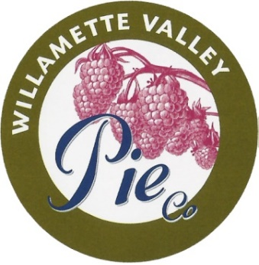  Name & Phone |  | 9” Large Pies  $15.50 |  |  |  | Artisan  $17.50 |  | Cream Pie  $17.50 | Cobblers  $10 |  |  | IQF Fruit  $9 |  |  | Mini Pies 6 of 1 flavor or variety pre-pack  $30.25 |  |  |  |  |  | Totals
 |  | American Apple | Cherry Crunch | Marionberry | Raspberry/Rhubarb | Caramel Apple Streusel | Peach Raspberry Streusel | Seasonal Cream Pie Pumpkin Chiffon | Forest Berry | Peach | Marionberry | Blueberry | Peach | Strawberry | Apple | Cherry | Marionberry | Peach | Raspberry/Rhubarb | Variety Pack- 1 Apple,  1 Cherry, 2 Marionberry,  1 Peach, 1 Rasp/Rhub. | Total Items | Total Due
Product Sub-totals
Page ______of______ Total Items_______________________ Total Dollars_____________________

Thank you for considering the products of Willamette Valley Pie Company and for supporting local fund-raising groups!! If you have questions about our company, products, or fund raising for your group, please contact us at www.wvpie.com or 503-873-7437.

All Natural Handmade Pies

• All-natural ingredients, no preservatives, no GMO’s
• Pie crusts hand-rolled, hand-filled and crimped
• From the freezer to your oven with easy directions
• Two crust pies are trans-fat free, dairy free, & Vegan
• 9-inches and a full 40 ounces of heaven

American Apple Pie
Tart Granny Smith apples blended with just the right amount of cinnamon and sugar to give you a truly old fashioned apple pie taste.
Cherry Crunch Pie
Ripe, red, plump, whole cherries are packed into a hand rolled crust then topped with a flour, sugar, butter and sliced almond crunch for a perfect combination of flavors and texture.
Marionberry Pie
Marionberries are packed tightly to produce the delightful taste from Marion County. Add a scoop of ice cream and it will become everyone’s favorite.
Raspberry/Rhubarb Pie
Tangy rhubarb is added to mellow, sweet, red raspberries to create this wonderfully unique pie that is both tart and sweet.

Artisan Pies

• Same qualities as the pies above.
• Cream pies are “Thaw and Serve”
• Streusel= Ground Oats, brown sugar and 2 secrets
Caramel Apple Streusel Pie
Although the crust is nearly “just like grandma used to make,” Grandma never came close to this one! It isn’t really her fault….who knew little caramel bits and apples would become such a popular combination? Then to top it off, literally, the streusel topping bakes to a golden perfection of crispy, crunchy and sweeeeet! Yum.
Peach-Raspberry Streusel Pie
OK…this is three levels of delicious all in the name of the pie!! Start with our handmade pie crust. Yes, it’s true only a few are able to attain the title of Pie Pincher to finish the crust! This pie is packed with fruit….lots of it. Almost 2 pounds!! Over the top goes the amazing Streusel Topping. Who knew all the ingredients would form a Pie of Perfection???
“Thaw & Serve” Pumpkin Chiffon Pie!
Delicate pumpkin mousse, ground pie spices and fresh whipped cream form a four-layered masterpiece. Wonderful for pumpkin lovers and the holiday season. Order an extra!!

Fruit Cobblers

• Fresh, local fruits and berries
• Delicious cake texture with a crumble topping
• 26 ounces serves 5-6 people
• Simply bake in your oven

Forest Berry Cobbler
A delightful combination of marionberries, blackberries and blueberries.
Peach Cobbler
Beautiful and tender peaches make this a naturally delicious dessert anytime.
Marionberry Cobbler
This is a smaller, crustless version of our pie. Serve warm with ice cream……WOW!
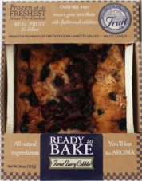
Individually Quick Frozen Fruits

• 2 pound bags of ripe, firm, fresh frozen fruits
• Loaded with antioxidants
• Healthy Snacks
• Great for cooking, baking, snacking, and smoothies

Available in:
Blueberry, Peach, Strawberry
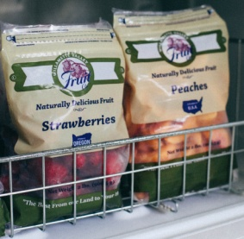
Mini Pies

“Pie for you or pie for two”
• Handmade 5”, 10-ounce pies
• All-natural ingredients, no preservatives, no GMO’s
• Two crust pies are Vegan, dairy & trans-fat free
• Pie crusts are hand-rolled, hand-filled and crimped
• Freezer to oven with easy directions
• Available in cases of 6

Choose from:
6 Mini Apple Pies
6 Mini Cherry Pies
6 Mini Marionberry Pies
6 Mini Peach Pies
6 Mini Raspberry/Rhubarb Pies
OR
Our Variety Pack: 1 Apple,
1 Cherry, 2 Marionberry,
1 Peach, 1 Raspberry/Rhubarb
